 | Maroubra Seals Snooker  Organiser cheat sheet — running a competition night

The night in five taps. Log in → Start Competition → ▶ Start each match (pick table) → ■ Record result (winner + buy-back) → Close entries once nobody else is coming. Repeat until the Final. Every tap undoable.

1. Log in
- /admin/login, or Organiser Login on the public page. Type code → Log in. Code = your name on every change.
- "Code not accepted" = typo or old code. Retry.
- Device stays logged in week to week. Admin ▾ → Log out to sign out.

2. Set up
- Name (defaults to date). Bracket size 16 or 32. Size locked after start.
- Tick who is here in Club players → Add ›. + New player for anyone not on the list.
- Check summary line → Start Competition → Start the night.
- Draw is random. Late entries and buy-backs still allowed while entries open.

3. Start a match
- ▶ Start on the match box → tap a free table. Clock starts: 25 min, server-side, survives refresh.
- Number beside a name = rating, lower is better. Green +7 = weaker player's start (⅔ of the difference).
- Wrong match? Tap box → ⤺ Cancel start.
- Clock at zero: spoken "Match timed out". Match stays live until result recorded.
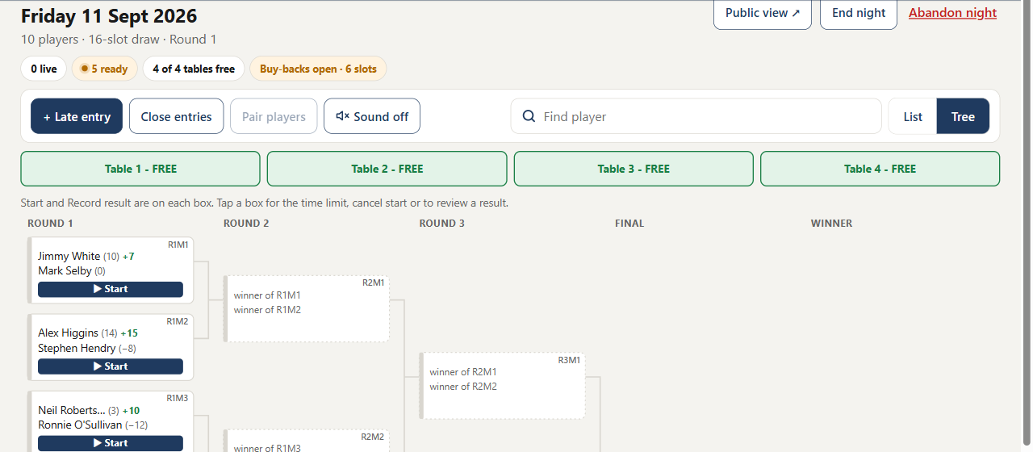
Round one drawn. ▶ Start on every ready match; table strip above.

4. Record result
- ■ Record result on the live box.  - Who won? tap winner.  - Buy-back decision tap buys back · $2 or declines. Round-one loser only, once. Round two loser is out.  - Buy-back = one open slot, first come first served. None left → greyed, loser out.  - Save result. Winner moves up at once. Buy-back goes to a random open round-one slot.  - Wrong result? Tap box → Review result. OK until winner's next match starts. After that, Override. | 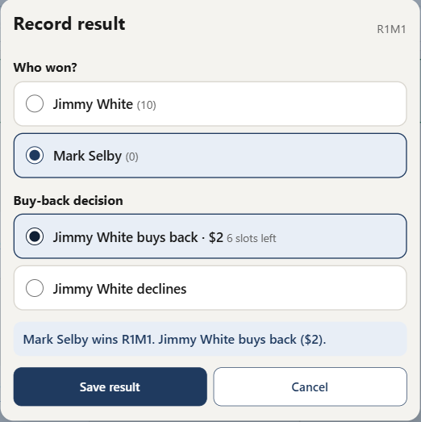  Save greyed until winner and buy-back chosen.

5. Close entries
- Never closes by itself. Close once every round-one loser has been offered a buy-back and nobody else is coming.
- Close entries (toolbar) → card lists lone round-one players, each gets a free pass → Close the window.
- After: round-one losers out, late entries refused, lone players climb by free pass.
- Closed by mistake? More ▾ → Override → Reopen buy-backs.

6. Finish
- Keep starting and recording. Winners climb automatically. AWAITING OPPONENT = other side not decided yet.
- Final saved → Ratings review opens. Check proposed handicaps → Save rating changes → lands on History.
- Out of time: End night (top right). No winner. Not undoable.
- Abandon night (red): scraps the night, back to Setup. Nothing counts.

7. Reference

Menus
Menu | For
Tonight | Bracket, all match controls.
Players | Club list and ratings. Add, edit, deactivate.
More ▸ Setup | Only while no night running.
More ▸ Ratings | End-of-night review. Opens itself.
More ▸ History | Past nights, handicap grid. Read-only.
More ▸ Settings | Time limit, tables, rating adjustment.
More ▸ Override | Escape hatch when a button refuses.
Admin ▾ ▸ Log out | Signs this device out.

Tonight toolbar
Control | Does
+ Late entry | Player arriving after the draw. Takes one open slot. Gone after Close entries.
Close entries | Section 5.
Pair players | Two waiting round-one players play now, random pairing.
Sound on / off | Spoken timed-out alert.
Find player | Where a player is: playing, waiting, out.
List | Tree | Two views of the same draw. Remembered on this device.
Public view ↗ | Read-only page everyone watches.
End night / Abandon night | Section 6.

Match box (tap it)
 | 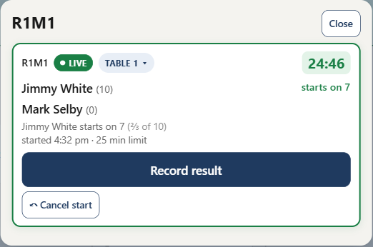  Record result full width, rarer taps small.
  Control | Does
  Table ▾ | Move live match, or pre-note table for a ready match.
  25 min limit | Change for this match only (ready match).
  ⤺ Cancel start | Un-start. Clock and table cleared.
  Review result | Change a saved result.

Players
Action | Notes
+ Add player | Name + rating. −100 to 200, lower is better, negative is normal.
Edit ▸ Save | Overrides rating. Logged with name, time, reason. Never changes tonight's draw.
Inactive | Hidden, never deleted. Not allowed for a player in tonight's draw.

Settings
Setting | Notes
Match time limit | Default 25. Affects matches not yet started.
Snooker tables | Default 4. Cannot drop below a live table.
Rating adjustment | Default top 3 by −1, bottom 3 by +2. Locked once the night starts.

Master override
Each action confirms first, then logs your name under Recent overrides.
Action | Does
Add a player | Any time, even closed or full (grows 16 → 32 first).
Remove | Unstarted matches deleted. A won match is voided back.
Reset | Match back to not started. Winner pulled from next round.
Delete | Match removed. Both players back to waiting.
Pair two waiting players | Chosen pair, no randomness.
Grant / Revoke free pass | Next round without playing, or take it back.
Reopen buy-backs | Undoes Close entries.
Grow bracket 16 → 32 | Adds slots 17–32. Cannot shrink.
Abandon this competition | Same as Abandon night.

Public page
Front page of the site. No login, nothing to change, refreshes every 10 s. Tabs: Tonight (my match, tables, playing now, up next, results), Draw, Players. Public view ↗ opens it.

